Let’s separate the CPU operation modes to this document.
CPU MODES EXPLAINED: PART 1 – REAL MODE (THE WILD WEST OF COMPUTING)
⚙️ What Even Is a CPU Mode?
Before we get deep, here’s the vibe:
A CPU “mode” is like the operating style of the processor.
It defines what the CPU is allowed to do:
- How much memory it can touch.
- Whether it has access control/security.
- What kind of instructions and registers it can use.
It’s like your CPU switching between “beginner,” “intermediate,” and “pro” modes depending on what it’s trying to run.

🧱 Real Mode: The 16-Bit Legacy Arena
This is the original mode of the x86 CPU family. Born with the 8086 processor (1978), and every modern x86 CPU still starts in Real Mode when powered on, even your Core i9 or Ryzen 9.
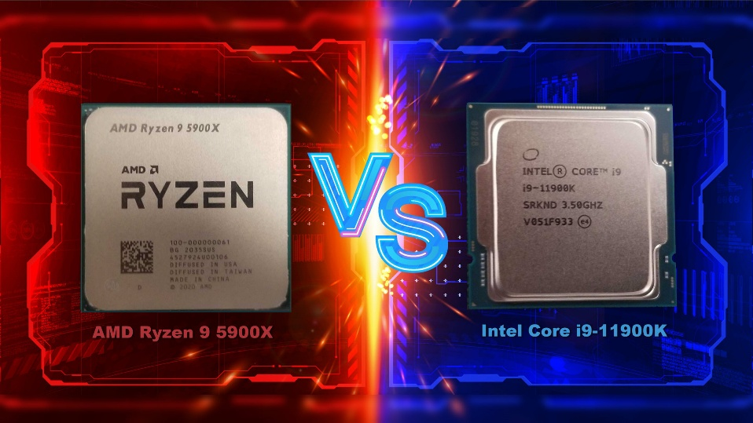

🔍 Key Traits of Real Mode:
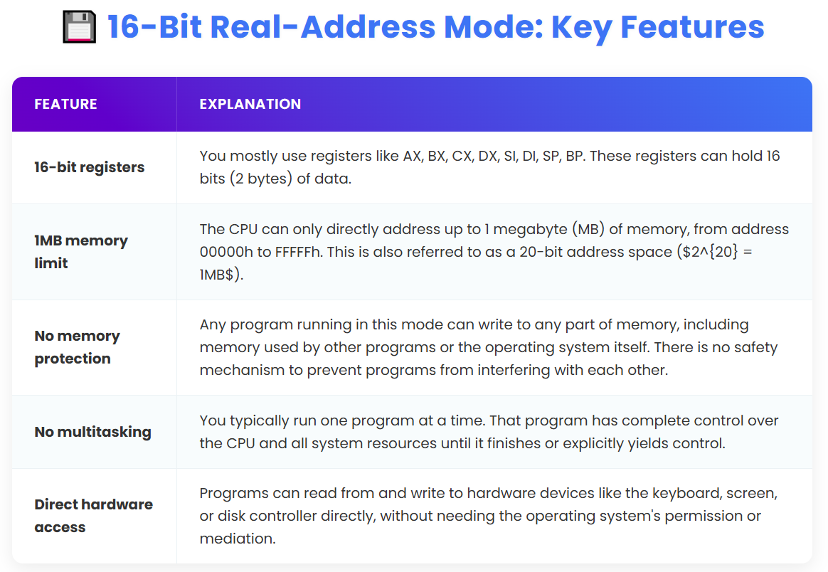
🧪 Addressing Style
Real Mode uses Segment:Offset addressing. It breaks up memory access like this:
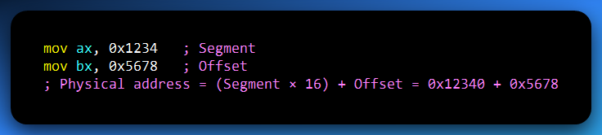
Basically: Segment × 16 (or left-shift 4 bits) + Offset. That’s how Real Mode squeezes 20-bit memory access out of 16-bit registers.
I know you didn’t get anything, lets revisit this madness about 16-bit real mode. Okay, I already made the image and html for you to go read, this is too hard to just write it out here.
You’ll not meet this stuff a lot, this is just for the old systems, for understanding.
🎮 Where You’ll Still See Real Mode in Action:
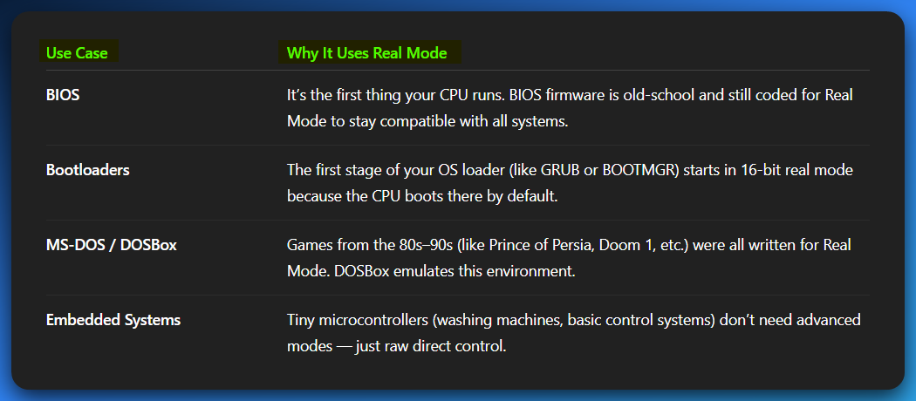
🚫 Why Modern OSes Abandoned Real Mode:
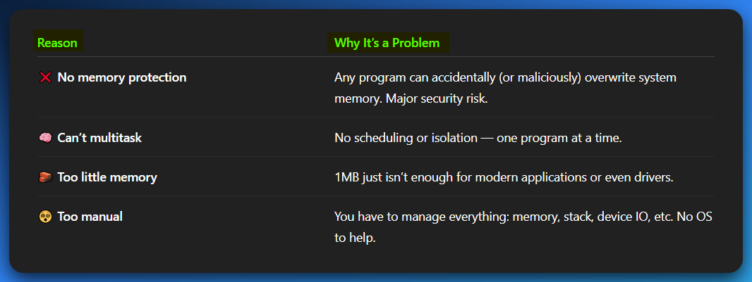

⚠️ That’s why modern OSes like Windows 10/11 or modern Linux don’t allow 16-bit Real Mode programs to run natively anymore. You need emulators or virtual machines.
Analogy Time:
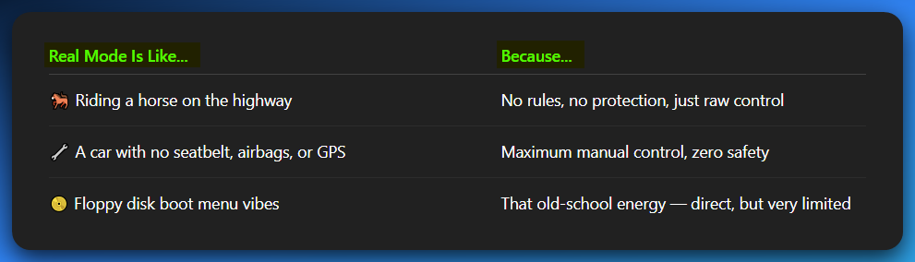
Summary: Real Mode
- ✅ 16-bit legacy mode — max 1MB memory
- ✅ No protection, no multitasking
- ✅ Still used in BIOS, bootloaders, and tiny embedded systems
- ❌ Not suitable for modern multitasking OSes
- ❌ Needs emulation on modern 64-bit systems

Let’s go to 32-bit. Remember, we’re using the 007 html file, just expanding that one for maximum impact and understanding.

🛡️ 32-Bit Protected Mode – The Secure Apartment Building of Computing
What is Protected Mode?
Protected Mode was a game-changer when it dropped with the Intel 80386 processor.
This mode introduced true multitasking, memory protection, and virtual memory — which are core features of every modern OS.
Imagine going from a wild jungle (Real Mode) to a secure, gated apartment complex where every resident (program) has their own key, walls, and alarm system.

Key Features of Protected Mode:
Memory Protection: Each program runs in its own isolated memory space, so if it tries to access memory it doesn’t own, it crashes without affecting other programs or the operating system.
🌐 Virtual Memory: Every application is given the illusion of having access to a full 4GB (or more) of memory, even if the physical RAM is smaller. The operating system makes this possible by using disk space as overflow, through a technique called paging.
🔄 Multitasking: The CPU can rapidly switch between multiple programs or tasks, allowing you to run things like Chrome, Spotify, and Visual Studio simultaneously without conflict.
🧩 Privilege Levels (Rings): The CPU enforces a hardware-based separation between user-mode (applications) and kernel-mode (the OS). This ensures that applications cannot directly interfere with or compromise the operating system.
📦 Flat Memory Model Support: Although segmentation still technically exists, modern systems often use a flat memory model where memory is accessed linearly, byte by byte, making addressing simpler and more intuitive.
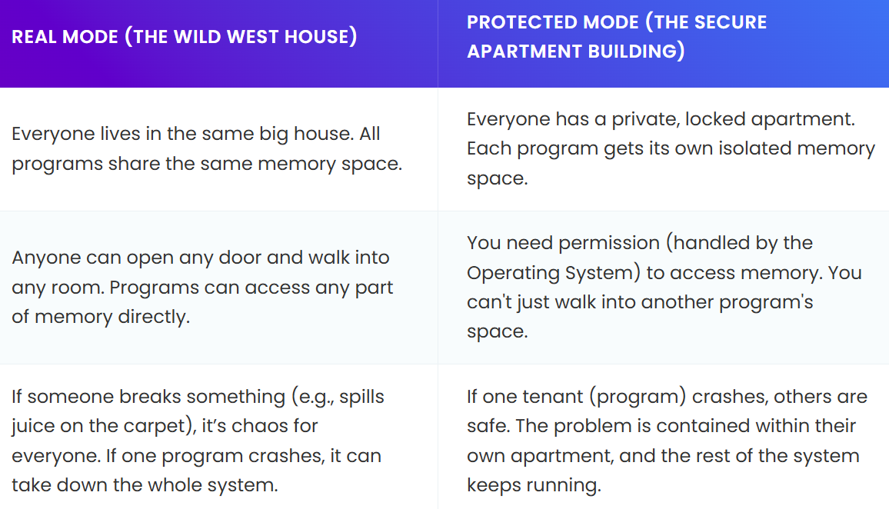
🗂️ Where Protected Mode Is Used Today (And why):
🪟 Windows 32-bit Operating Systems like Windows XP, Vista, 7, 8, and 10 (32-bit editions) rely entirely on Protected Mode to function.
🎮 Older games and applications from the 2000s were mostly compiled as 32-bit programs, which means they still run perfectly well in Protected Mode environments.
💡 WoW64 (Windows-on-Windows 64-bit) allows modern 64-bit versions of Windows to run older 32-bit applications by emulating a Protected Mode environment for compatibility.
🐧 32-bit Linux distributions, such as Ubuntu x86, older versions of Raspberry Pi OS, and many embedded Linux systems, still use Protected Mode under the hood.
🔧 MASM and NASM tutorials often teach Protected Mode (32-bit assembly) first because it's cleaner, simpler, and requires less setup than diving straight into 64-bit assembly.
🖱️ Legacy drivers and low-level tools are still sometimes compiled in 32-bit mode, even on modern systems, to ensure compatibility with older hardware or software layers.
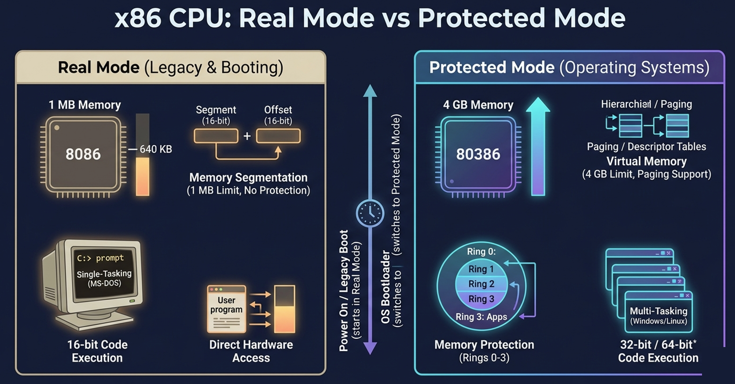
💡 Why 32-bit Protected Mode Was Such a Leap:
Before Protected Mode, you had:
- No app isolation
- No memory management
- No multitasking
- No security
After Protected Mode:
- You could have a full OS with apps crashing independently, virtual RAM, security per program, and multitasking.
That’s why OSes like Windows NT, Windows 95, and modern Linux were only possible with this mode.

💾 Registers in Protected Mode
You gain access to extended 32-bit registers:
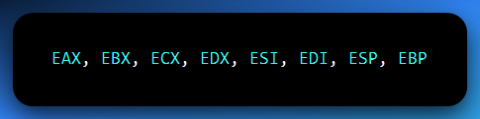
Also, segmentation is still there (DS, CS, ES, etc.), but most tutorials flatten it for simplicity.
Example:
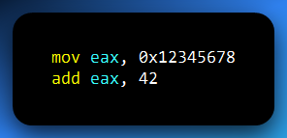
This assembly snippet moves the hexadecimal value 0x12345678 into the 32-bit EAX register, then adds 42 to it.
Both instructions operate directly on 32-bit data, which is standard in protected mode environments.
In 32-bit protected mode, registers like EAX, EBX, and ECX are designed to handle 32-bit values, and memory addressing is structured around these 32-bit operations — making this kind of code the norm for systems like 32-bit Windows and Linux.

Register Sizes (x86/x86-64 Architecture):
Before we continue, let’s address a small issue here:

8-bit registers: AL, AH, BL, BH, CL, CH, DL, DH
Can hold values from 0x00 to 0xFF (0 to 255 unsigned, or -128 to 127 signed).
Example:
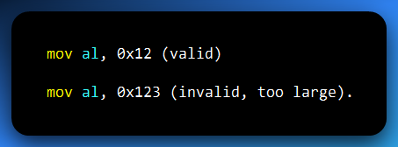
16-bit registers: AX, BX, CX, DX, SI, DI, SP, BP
Can hold values from 0x0000 to 0xFFFF (0 to 65,535 unsigned, or -32,768 to 32,767 signed).
Example:
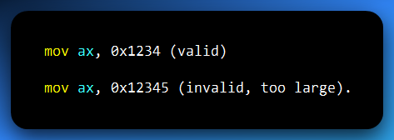

32-bit registers: EAX, EBX, ECX, EDX, ESI, EDI, ESP, EBP
Can hold values from 0x00000000 to 0xFFFFFFFF (0 to 4,294,967,295 unsigned, or -2,147,483,648 to 2,147,483,647 signed).
Example:
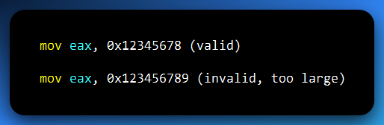
64-bit registers: RAX, RBX, RCX, RDX, RSI, RDI, RSP, RBP
Can hold values from 0x0000000000000000 to 0xFFFFFFFFFFFFFFFF (0 to 18,446,744,073,709,551,615 unsigned, or -9,223,372,036,854,775,808 to 9,223,372,036,854,775,807 signed).
Example:
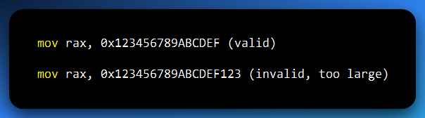
Checking if a Value Fits
Hexadecimal digits per register size:
- 8-bit: 2 hex digits (e.g., 0x12).
- 16-bit: 4 hex digits (e.g., 0x1234).
- 32-bit: 8 hex digits (e.g., 0x12345678).
- 64-bit: 16 hex digits (e.g., 0x123456789ABCDEF).

Example:
- mov eax, 0x12345678 → Valid (8 hex digits, fits 32-bit).
- mov eax, 0x123456789 → Invalid (9 hex digits, exceeds 32-bit). It won’t fit — the CPU will take only the lower 4 bytes – TRUNCATION.
- mov rax, 0x123456789 → Valid (fits in 64-bit).

What Happens if You Exceed the Limit?
Most assemblers (like NASM, MASM, FASM, GAS) will throw an error if you try to move a too-large value into a register.
Example (NASM error):
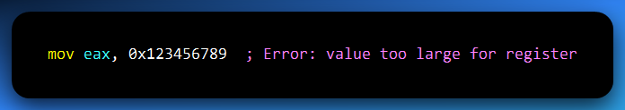
Some assemblers might truncate the value (keep only the lowest bits), but this is not reliable and should be avoided.

Truncation
Say you do:
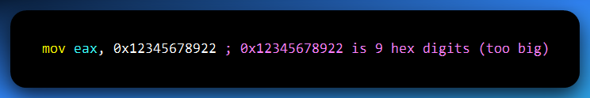
It won’t fit — the CPU will take only the lower 4 bytes (last 8 hex digits):
0x12345678922 → gets truncated to 0x345678922 → then only the last 8 digits → 0x45678922 (lower 32 bits).
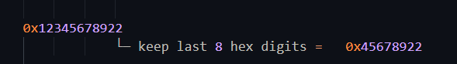
👎 The extra 0x1 at the beginning gets cut off silently. It’s like trying to pour 1.5 liters of soda into a 1-liter bottle. The rest just spills.

🦾 What Happens if You Use a Smaller Register?
Same logic, smaller limit:
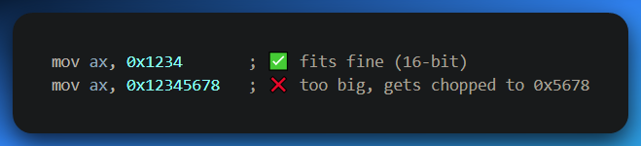
AX is only 16 bits → only takes last 4 hex digits.

🔥 Cheat Sheet: How Many Hex Digits per Register?
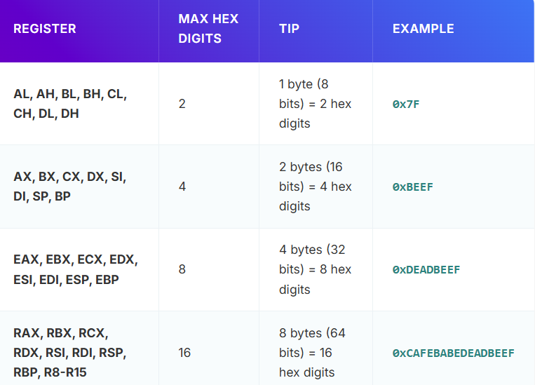
For the confused backbenchers, lets fix you:
✅ One Byte = 8 Bits = 2 Hex Digits
A byte holds 8 bits. Each hex digit represents 4 bits (aka a nibble).
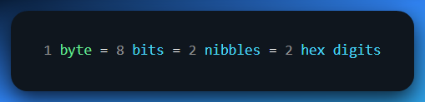
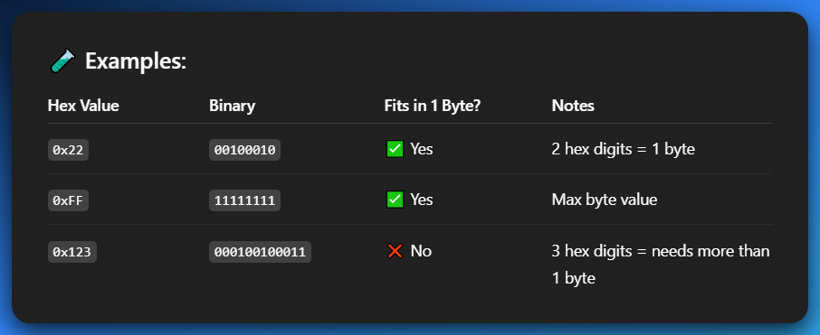
“If my value is 2 hex digits (like 0x7F, 0x22, 0xB4), it fits in a byte.”

⚠️ Don't Confuse with Decimal
Some decimal numbers look small but still take more than 1 byte:
- 200 (decimal) = 0xC8 → ✅ fits
- 300 (decimal) = 0x12C → ❌ 3 hex digits → needs 2 bytes

Special Cases:
Sign Extension: If you move a smaller value (e.g., mov eax, -1) into a larger register (e.g., rax), the value is sign-extended.
Zero Extension: Moving unsigned values (e.g., movzx eax, al) fills upper bits with zeros.
We’ll see these in future topics.
Key Takeaway:
- Count the hex digits to ensure the value fits the register.
- Assemblers will warn you if the value is too large.
- Reverse Engineering Tip: When analyzing code, check the register size to understand how much data is being manipulated.
- 1 byte = 2 hex digits (a nibble each).
- AL / AH can store anything up to 0xFF.
- When writing hex, count the digits to know how many bytes you're dealing with.
- Don’t confuse hex with regular base-10 numbers.

⚠️ 32-bit protected mode is Legacy today
But still essential for Reverse Engineering and Kernel work… etc

🌐 64-Bit Long Mode – The Skyscraper City of Modern CPUs
What is Long Mode?
Welcome to the current era of computing. Long Mode is how modern 64-bit CPUs run your operating systems and apps today.
Introduced with AMD64 (yup, AMD beat Intel here), this mode unlocked way more RAM, better performance, and modern security features — without throwing away what made Protected Mode great.
Think of Long Mode like a future-proof skyscraper city:
Massive vertical space (more memory), more elevators (registers), and smarter infrastructure (paging, security).

📦 Long Mode = Protected Mode ++
Technically, Long Mode is a supercharged version of Protected Mode.
It still supports:
- Paging (virtual memory)
- User/kernel isolation
- Multitasking
...but adds 64-bit registers and 64-bit address spaces.

⚙️ Key Features of Long Mode:
- 🧠 64-bit Registers: In Long Mode, traditional 32-bit registers like EAX, EBX, and ECX are replaced with their 64-bit counterparts — RAX, RBX, RCX, etc. In addition, the architecture introduces eight brand-new general-purpose registers: R8 through R15, giving developers more flexibility and faster data handling.
- 💾 Huge Address Space: Long Mode unlocks a theoretical memory address space of up to 16 exabytes (that’s 18,446,744,073,709,551,616 bytes). In practice, most modern CPUs support up to 256 TB of addressable space, which is still astronomically higher than 32-bit limits.
- 💨 Faster Performance: With more registers and wider 64-bit data paths, CPUs in Long Mode can handle larger numbers and datasets more efficiently — which means faster calculations, better multitasking, and improved performance for heavy applications.
- 🧱 RIP-Relative Addressing: Long Mode introduces RIP-relative addressing, which allows code to access memory locations relative to the current instruction pointer (RIP). This makes position-independent code (PIC) easier to write and more secure — something modern operating systems rely on for features like shared libraries and code randomization.
- 🔐 Stronger Isolation and Security: Long Mode supports a hardened separation between kernel and user space, along with advanced security features like the NX (No-eXecute) bit, ASLR (Address Space Layout Randomization), and SMEP (Supervisor Mode Execution Prevention). These features work together to protect against modern memory-based attacks and vulnerabilities.


💻 Real-World Use Cases of 64-bit Long Mode (a.k.a. Where It’s Actually Used)
🪟 Modern Operating Systems: Pretty much every current OS — Windows 10, Windows 11, macOS, and modern Linux distros — runs entirely in 64-bit Long Mode. If your computer is less than 15 years old, you're already living in it.

📹 Heavy-Hitter Apps (Video, Databases, etc.): Apps like video editors, big databases, and 3D rendering engines need access to more than 4GB of RAM — which 32-bit systems just can't handle. Long Mode makes that possible.

🎮 Modern Games: Games today eat RAM like snacks. 8GB+ is standard, 16GB+ is common — and that means they have to be 64-bit. Most AAA titles won’t even launch in a 32-bit world.

🔬 Scientific Computing & Machine Learning: When you’re working with huge arrays, neural networks, or massive datasets, 32-bit systems just tap out. Long Mode opens the door for processing at scale — think AI, simulations, bioinformatics, physics engines, all that jazz.

🛡️ Malware (and Anti-Malware): Modern malware is built to target 64-bit OSes, and defenders (a.k.a. reverse engineers like you) need 64-bit tools to analyze and unpack them. Long Mode isn’t just for legit programs — it’s the battlefield for digital warfare.

🔧 Reverse Engineering EXEs: Most executables on a 64-bit Windows system use the PE64 format (Portable Executable, 64-bit). If you're cracking, tracing, or dissecting apps, you gotta know how 64-bit registers, memory layout, and instructions work — or you'll be totally lost.
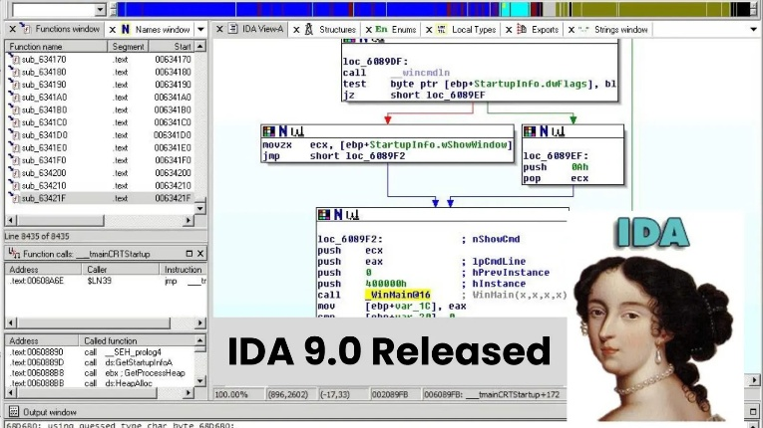
📏 Register Breakdown in Long Mode
In Protected Mode (32-bit), you had:
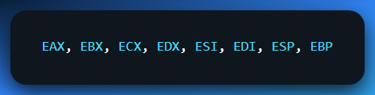
Now in Long Mode (64-bit), you’ve got:
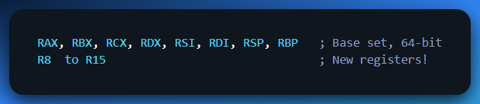
Here are their full names:
🧱 RBX – The Extended Base Register
Used for holding base addresses in memory.
Think: a pointer to the start of your giant data structure — like the foundation of a skyscraper.

🔁 RCX – The Extended Count Register
Used in loops, counts, and string operations.
Think: a digital clicker counting how many reps your CPU has left to do.

📤 RDX – The Extended Data Register
Handles I/O and large-number math.
Think: your CPU’s multipurpose toolbelt — for division, data transfer, etc.

📦 RSI – The Extended Source Index
Points to where data is coming from (like for string/memory ops).
Think: a chef’s hand reaching into the pantry — grabbing the source.
📥 RDI – The Extended Destination Index
Points to where data is going.
Think: that same chef dumping the food into a bowl — the destination.

📚 RSP – The Extended Stack Pointer
Always points to the top of the stack.
Think: a stack of plates — this register tracks the one on top.

📌 RBP – The Extended Base Pointer
Used to anchor the current function’s stack frame.
Think: a fixed bookmark inside your temporary memory, pointing to where local variables live.

And yes, each of these can be broken down further:
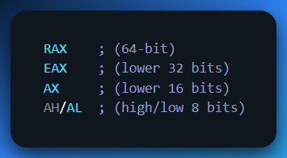
So, you still get backward compatibility with older 32-bit and 16-bit code, but now with way more horsepower.

R8 to R15 – The New Recruits (64-bit Only)
When CPUs evolved from 32-bit to 64-bit, they didn’t just stretch existing registers (like EAX → RAX).
When we made the jump to 64-bit, Intel said:
“You know what? 8 general-purpose registers just ain’t enough anymore.”
So, they gave us 8 more: R8 to R15.
These are full 64-bit general-purpose registers — just like RAX, RBX, etc. — but exclusively available in 64-bit mode (Long Mode). You won’t see these in 32-bit assembly at all.

What They're Used For:
- Used heavily in function parameter passing (the Windows/Linux 64-bit calling conventions rely on them)
- Great for extra temporary storage when your code needs more than the classic 8 registers
- Super handy in loop unrolling, SIMD routines, or low-level optimization
- You’ll see malware, obfuscators, and compilers use them for sneaky tricks or performance
So instead of:
We now get:
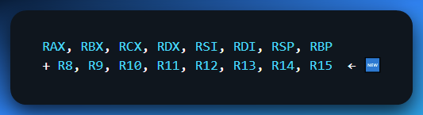
That’s 16 total general-purpose registers in 64-bit mode. Huge boost.
🎮 Why do we care about R8–R15?
1. Function Parameter Passing in 64-bit Linux (System V ABI)
When you call a function in 64-bit Linux (or compile with GCC, Clang, etc.), the first six arguments are passed using registers (not on the stack like in 32-bit).
The order is:
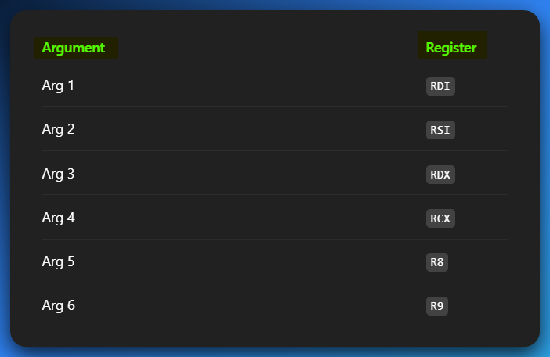
This table shows a common calling convention, specifically for Linux (and other Unix-like systems) on x86-64 architecture, often referred to as the System V AMD64 ABI.
For the first six arguments, it prioritizes using specific general-purpose registers, including the "new" registers like R8 and R9, to pass data directly to a function, which is much faster than pushing them onto the stack.
Example:
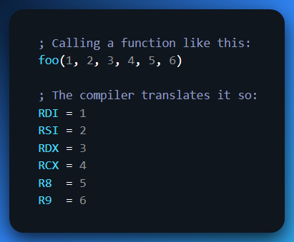
That’s why R8 and R9 aren’t optional weird extras — they are baked into how functions work in 64-bit!

📬 What about Windows?
In Windows 64-bit (Microsoft x64 calling convention), it’s a little different:
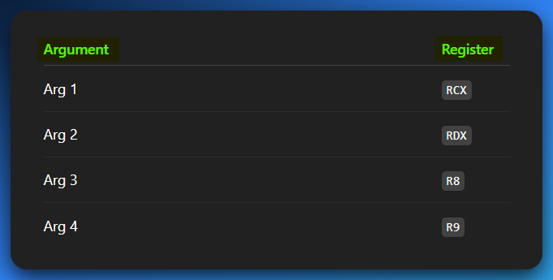
So, in both Linux and Windows, R8 and R9 are used early in parameter passing.

🧩 Sub-registers of R8–R15
Just like how RAX has smaller siblings:
- EAX (32-bit)
- AX (16-bit)
- AL (8-bit low)
- AH (8-bit high)

The new registers R8–R15 also have sub-registers:
In 64-bit systems, Intel introduced a set of new general-purpose registers: R8 through R15.
Just like the older AX, BX, CX, DX registers, these new 64-bit registers also have sub-registers that allow you to access smaller portions of their data (32-bit, 16-bit, and 8-bit parts).
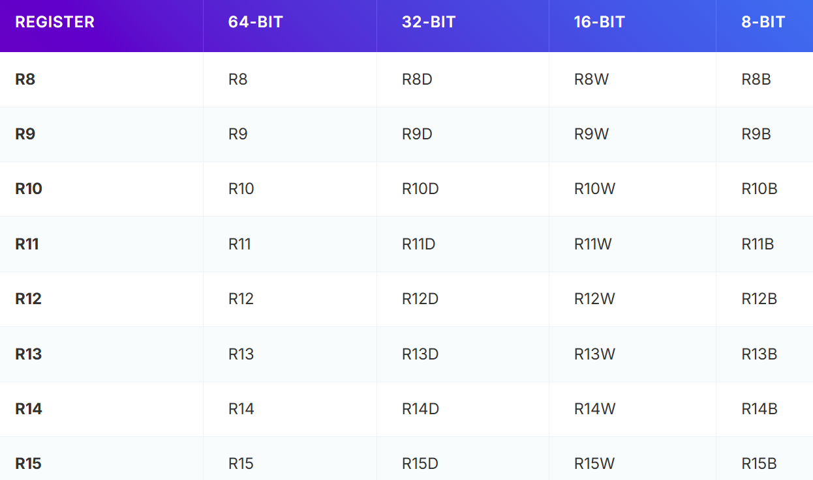
✅ So yes, you can move 8-bit values into R11B, 16-bit values into R12W, 32-bit values into R9D, and so on.
✅ This works just like how you'd use AL (8-bit), AX (16-bit), or EAX (32-bit) with the legacy RAX register.
✅ This flexibility allows for efficient manipulation of data of different sizes within the larger 64-bit registers.

🧪 Real Usage
Example 1 – Simple data move
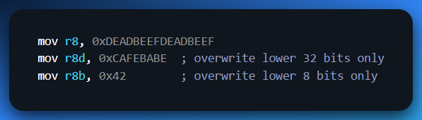
Example 2 – Passing function args in Linux
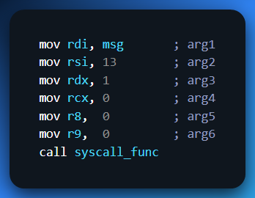
🎯 Why This Matters for You:
- If you're writing shellcode, reversing malware, or working on system-level C or C++, you must understand how args are passed.
- If you're building a compiler, parser, or learning ABI design – this is ground truth.
- If you're debugging a crash and see R8 = 0x0BADF00D – you now know it might be parameter 5.

TLDR – R8 to R15 in 64-bit Assembly (Cleaned Up)
R8 to R15 are extra general-purpose registers introduced in 64-bit mode — they don’t exist at all in 32-bit Protected Mode. These registers give you more firepower for handling data, optimizing performance, and passing function arguments.
In the 64-bit calling convention (especially on Linux and Windows), they help carry function arguments:
- 🧾 Example: R8 and R9 come in right after RCX, RDX, RSI, and RDI.
- So, if you're writing shellcode, reversing binaries, or tracing sys-calls, you need to know their role.
Just like RAX breaks into EAX → AX → AL, these registers have sub-registers too:
- R8D–R15D → 32-bit
- R8W–R15W → 16-bit
- R8B–R15B → 8-bit
🔎 Why it matters: Long Mode didn’t just make registers bigger — it added more.
More registers = more freedom, more complexity, more control.
If you’re in 64-bit land, these are not optional knowledge. Period.

Memory Access in Long Mode
You now have:
- 64-bit flat address space
- Paging with 4 levels (PML4) to map virtual addresses
- Still no segmentation like in Real Mode — segmentation is mostly disabled (yay, simplicity!)
That’s why most 64-bit assembly tutorials say: "Forget segments. Think in pages."

🚧 Why 64-bit Mode Isn’t Always Taught First – Painful AF
- 🤯 It's more complex under the hood:
System calls don’t work the same — you can't just drop a casual int 0x80 anymore like it’s 2003. Instead, 64-bit uses a totally different ABI (Application Binary Interface), and the registers behave differently. The rules changed, and you gotta learn the new playbook.
- 🧠 Debugging is trickier:
You’re now juggling wider 64-bit registers like RAX, dealing with RIP-relative addressing (yeah, your instructions reference memory based on the current address), and following new calling conventions. It’s like graduating from checkers to 4D chess.
- 📉 Less hand-holding for beginners:
Most tutorials out there still cling to 32-bit, because it's simpler and easier to teach. That means you’ll find fewer guides, fewer StackOverflow answers, and more “figure it out yourself” moments. But hey…

